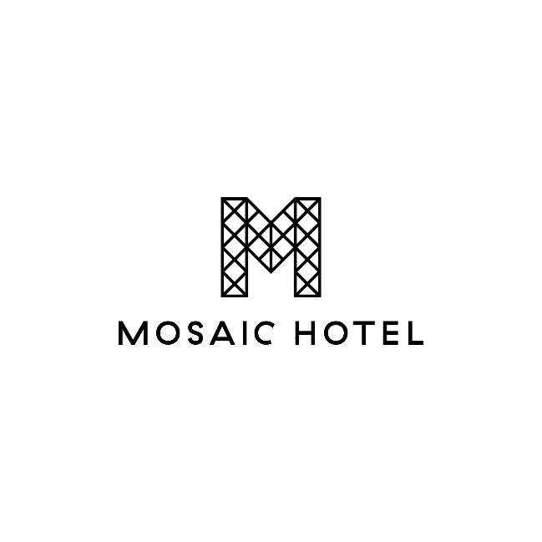

**GUINNESS + BRITISH LIONS PROMOTIONAL ACTIVITY**

Available Throughout the Entire Venue  
You Must Be 18+ Years Old to Participate

**How to Enter:**

* Purchase an Imperial Pint of Guinness and receive an instant scratch & win card.
* One entry card per Imperial Pint purchased.
* All prizes can be claimed in the Sports Bar.

**Bonus Prize for Mosaic Loyalty Members:**

* Exclusive draw for Mosaic Loyalty Members to win 2 Corporate Box Seats with Lion Nathan to the British Lions vs Australia/NZ Tour Game at Adelaide Oval – 12th July 2025.

SCAN TO SIGN-UP AS A MEMBER

**How to Enter the Bonus Prize Draw:**

1. Purchase an Imperial Pint of Guinness using your Mosaic Hotel Loyalty card or app QR code.
2. Staff must scan your QR code or swipe your membership card at the time of purchase.
3. Once the sale is processed, a receipt will be printed showing your name and membership number.
4. This receipt counts as your entry into the prize draw.

**Promotion Period:**

* Starts: 8:00 AM, 10th May 2025
* Ends: Midnight, 30th June 2025
* Winner Drawn: Tuesday, 1st July 2025
* Winner will be notified via email or phone.

**Important Notes:**

* Membership details must be accurate and match your ID.
* You must have a valid name, contact number, and email address on file.
* Patrons must be 18 years or older.
* Tickets are non-transferable.
* Management reserves the right to refuse prize awards if terms are not met.
* Terms and Conditions are subject to change at Management’s discretion due to unforeseen circumstances.